**2024 MISSOURI LABEL COMPETITION  
Jim Anderson, Executive Director**Missouri Wine and Grape Board  
Jefferson City, MO (800) 392-9463

**July 9, 2024**

**2024 LABEL JUDGES**

1. Arts council, gallery or art museum representative
2. Wine distributor or retail representative
3. Marketing, photography or graphic design industry representative

**AWARDS OFFERED**

1. Best Contemporary Label
2. Best Traditional Label
3. Best Wine Series
4. Best Alternative Packaging
5. People’s Choice Award

**RULES**

1. Entry forms must be completed **online** by 4:00 p.m. on **Friday, June 7, 2024**. ***Entry forms must be filled out online in entirety or they will be rejected.***
2. To be eligible for labels to be evaluated, the wine must be entered into the Missouri Wine Competition. The competition has a $40 entry fee but there will be no additional fee for the label competition portion.
3. ***Labels must be TTB approved to be submitted*,** with proof of authorization available upon request. Each wine entry must include the number of cases produced.
4. Wines must be shipped or delivered to a representative of the Wine & Grape Board at: Missouri Wine Competition, Missouri Wine & Grape Board, 1616 Missouri Blvd., Jefferson City, MO 65109, and must be received by close of business (4:00 p.m.) on **Friday, June 21, 2024.**
5. Infractions of rules and regulations will result in disqualification.
6. A winery may enter any wine so long as at least **22** cases of this same wine are bottled and available at the winery on August 8 (opening day of MO State Fair).
7. All entries must be produced in Missouri under a Missouri 22MS, LMS, or Domestic Wine License.
8. All wine entries must be fermented at the entering winery, must meet state and federal standards and become the property of the Missouri Department of Agriculture.
9. One of the fourbottles submitted will be used for the label competition. Wineries may be required to provide **one** case of each label winning wine for Missouri Wine and Grape Board promotional use.
10. Wine in alternative packages or containers less than 750 mL must submit 6 samples.
11. The Wine and Grape Board will procure and distribute the official awards.
12. Winners will be announced following the competition.
13. All wines will be judged based on the attributes of the label, originality, creativity and overall package presentation according to judge’s discretion. Judges will not taste wine during the label evaluation.
14. Entrants in “best wine series” may also be entered into other label categories. A label may not be entered into both the traditional and contemporary categories. Entries are limited to **five submissions per category** in both the traditional and contemporary categories.
15. Wineries must select **one label** as their entry for the People’s Choice Award. This label can also be entered in other categories. The winner will be selected by a vote on social media.

**LABEL CATEGORIES**

Best Contemporary Label

Best Traditional Label

Best Wine Series

Best Alternative Packaging

People’s Choice Award

**2024 Wine Label Competition Category Guidelines**

**Traditional Category**

Wine packaging within the traditional category should embody the simplistic and straightforward style of classic wine labels. Labels in this category may be more minimalistic and subtler in their incorporation of color, typography, and design. Common elements for traditional wine labels include monochromatic or muted color palettes, illustrations of the represented winery (or the winery’s seal), serif or cursive fonts, or ample open space between label elements. Wine packaging within the traditional category will be evaluated based on overall appearance and adherence to classic wine label design principles.

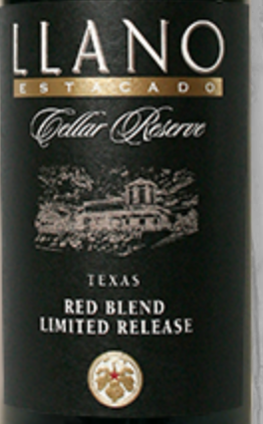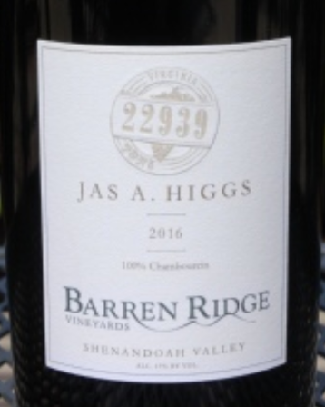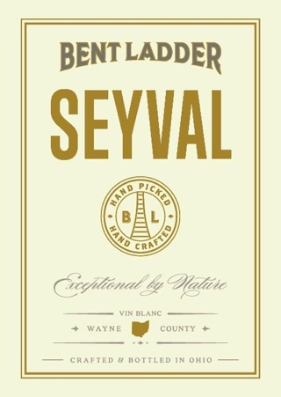 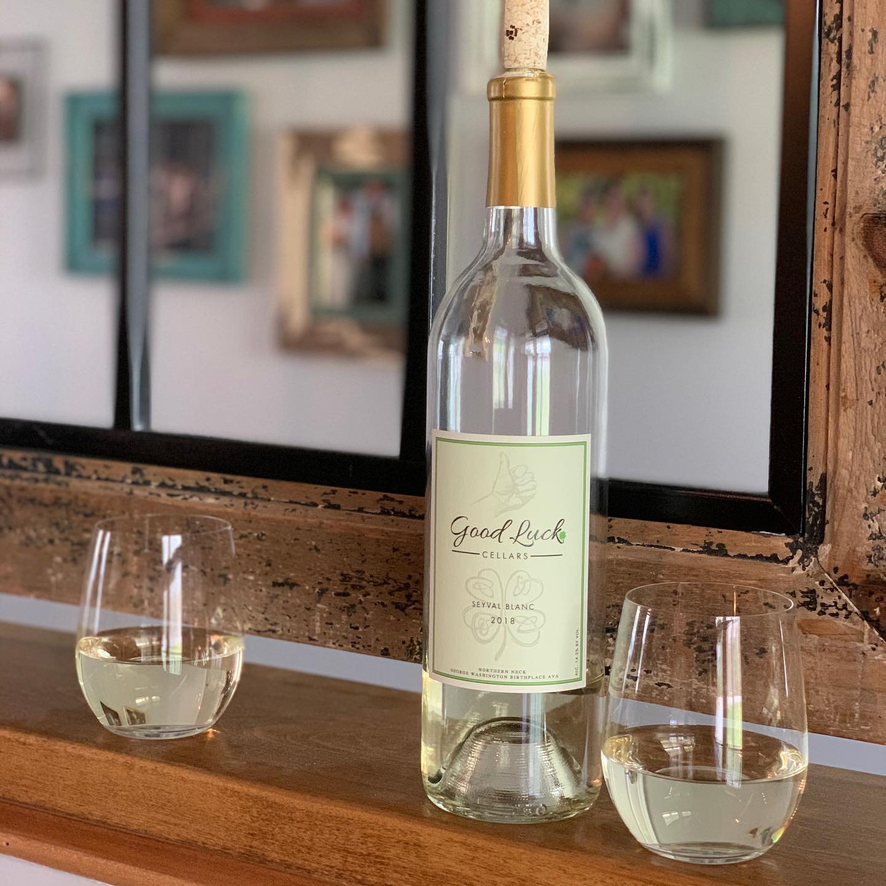

**Contemporary Category**

Wine packaging with in the contemporary category should embody the innovative and abstract style that defines contemporary artwork, which is the multi-faceted, complex examination of a topic. Labels in this category may be more visually captivating due to their incorporation of color, design, and unique artistic techniques. Elements incorporated in contemporary labels may include use of color, typography and graphic elements in a manner that allows the viewer to derive their own meaning from the artwork. Examples of contemporary elements could include the creative use of shapes and geometric patterns, incorporation of mixed media or alternative labeling methods. Wine packaging within the contemporary category will be evaluated based on overall appearance and inventive use of design principles.

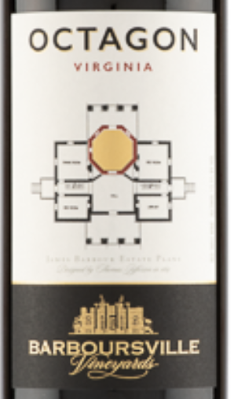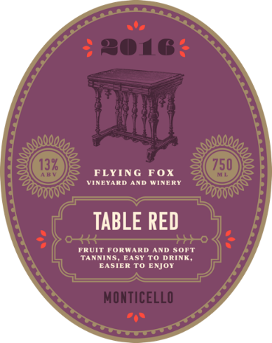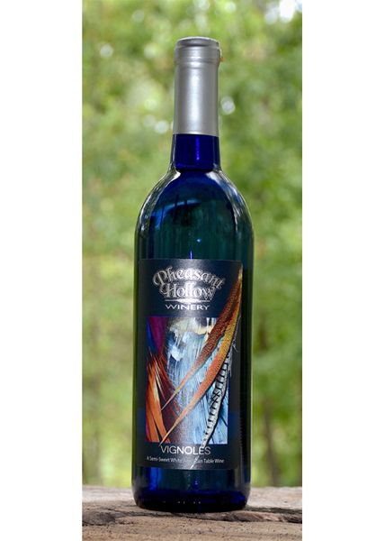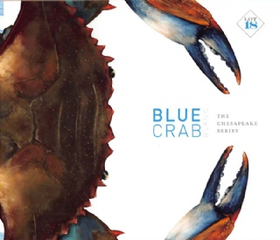

**Alternative Packaging**

In recent years some wineries have adopted alternative packing solutions to make wine more convenient for consumers or to offer wine in a variety of package sizes. Containers could include cans, pouches or boxes or other single use options that can be taken where glass containers are prohibited. Canned wines may be grouped in a 4 pack for distribution.

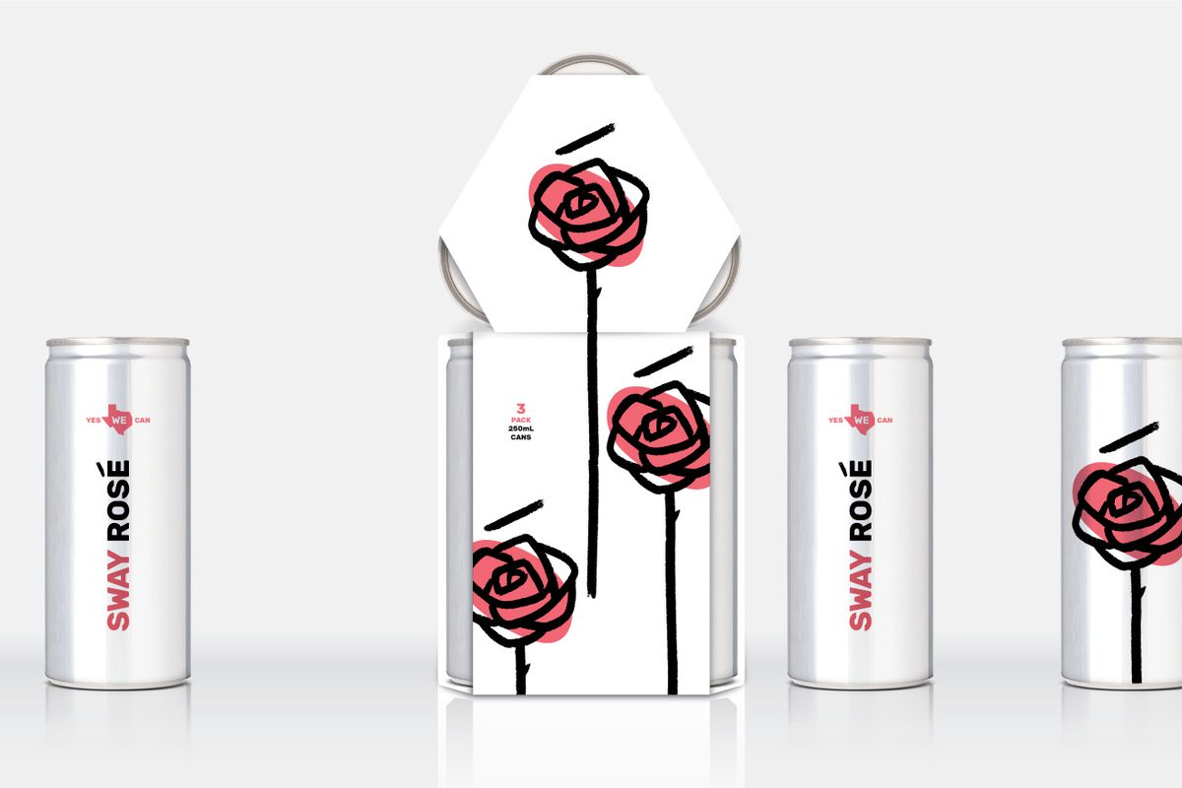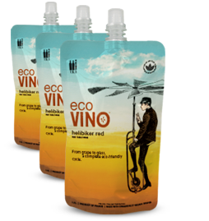

**Series Category**

Wine packaging within the series category should tie **three** or more wines together as a family or group. Packaging within the series category will be evaluated on their continuity of design elements or continued theme across individual labels. Alternative packages may also be grouped as a series.

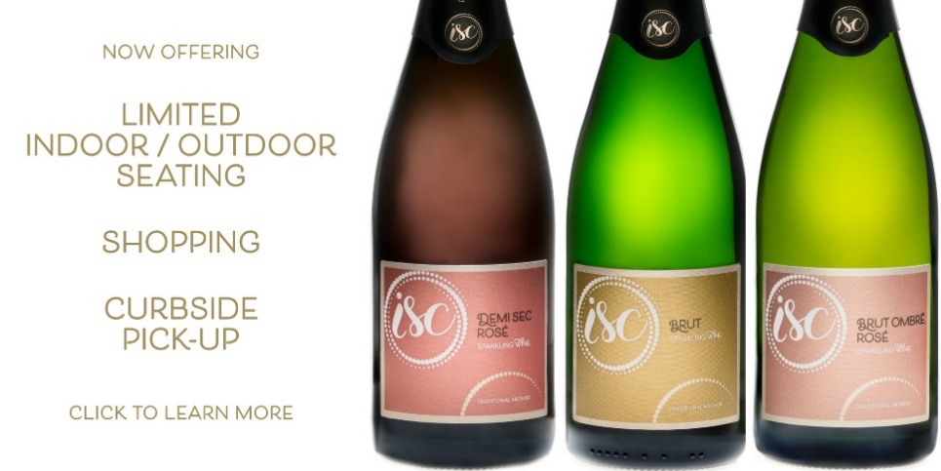

**People’s Choice**

All wines entered into the label competition will be photographed and posted on Missouri Wine and Grape Board social media to allow followers to vote for their favorite label.

*If you have questions about which category to enter your labels please call (800) 392-9463 or email* [*Missouri.wine@mda.mo.gov*](mailto:Missouri.wine@mda.mo.gov)*.*