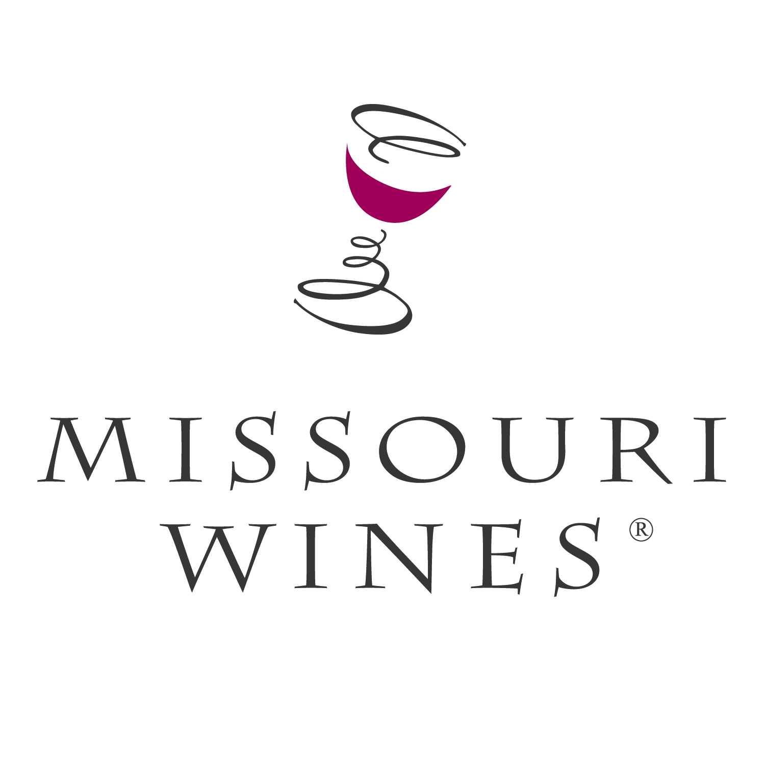

Missouri Wine & Grape Board

Donation Request Form
Top of Form

Please complete and submit this form if you would like to request a Missouri Wines gift basket, product, other collateral material, or if you would like to reserve the inflatable Missouri Wines bottle from the Missouri Wine and Grape Board for your event.

Event Name
Event Description

Location of Event
Date & Time of Event
Expected Attendance
Item Requested & Quantity Needed?
(See attached information before requesting inflatable bottle)

How will the item(s) be used?
Contact Person’s Name,
Telephone & Email
Additional Comments:

Signature(s)

Date

Email completed form to the Missouri Wine and Grape Board at missouri.wine@mda.mo.gov. All forms should be submitted at least one month prior to scheduled event, if possible. You may direct questions to 800-392-9463 or the email address above. We will review all requests very carefully. Please understand that due to the overwhelming amount of requests and limited supplies, we will not be able to grant all requests. Thank you for your interest in Missouri wines.

Missouri Wines Inflatable Bottle

Before requesting the Missouri Wines inflatable bottle, please consider the following:

- The Missouri Wines bottle is lent to events free of charge on a first come first served basis. You may reserve the bottle by completing the Missouri Wine and Grape Board’s Donation Request Form.

- It is the responsibility of the event contact to organize pick up and return of the bottle to our office in Jefferson City, Missouri – 1616 Missouri Boulevard – in the same condition in which it was loaned.

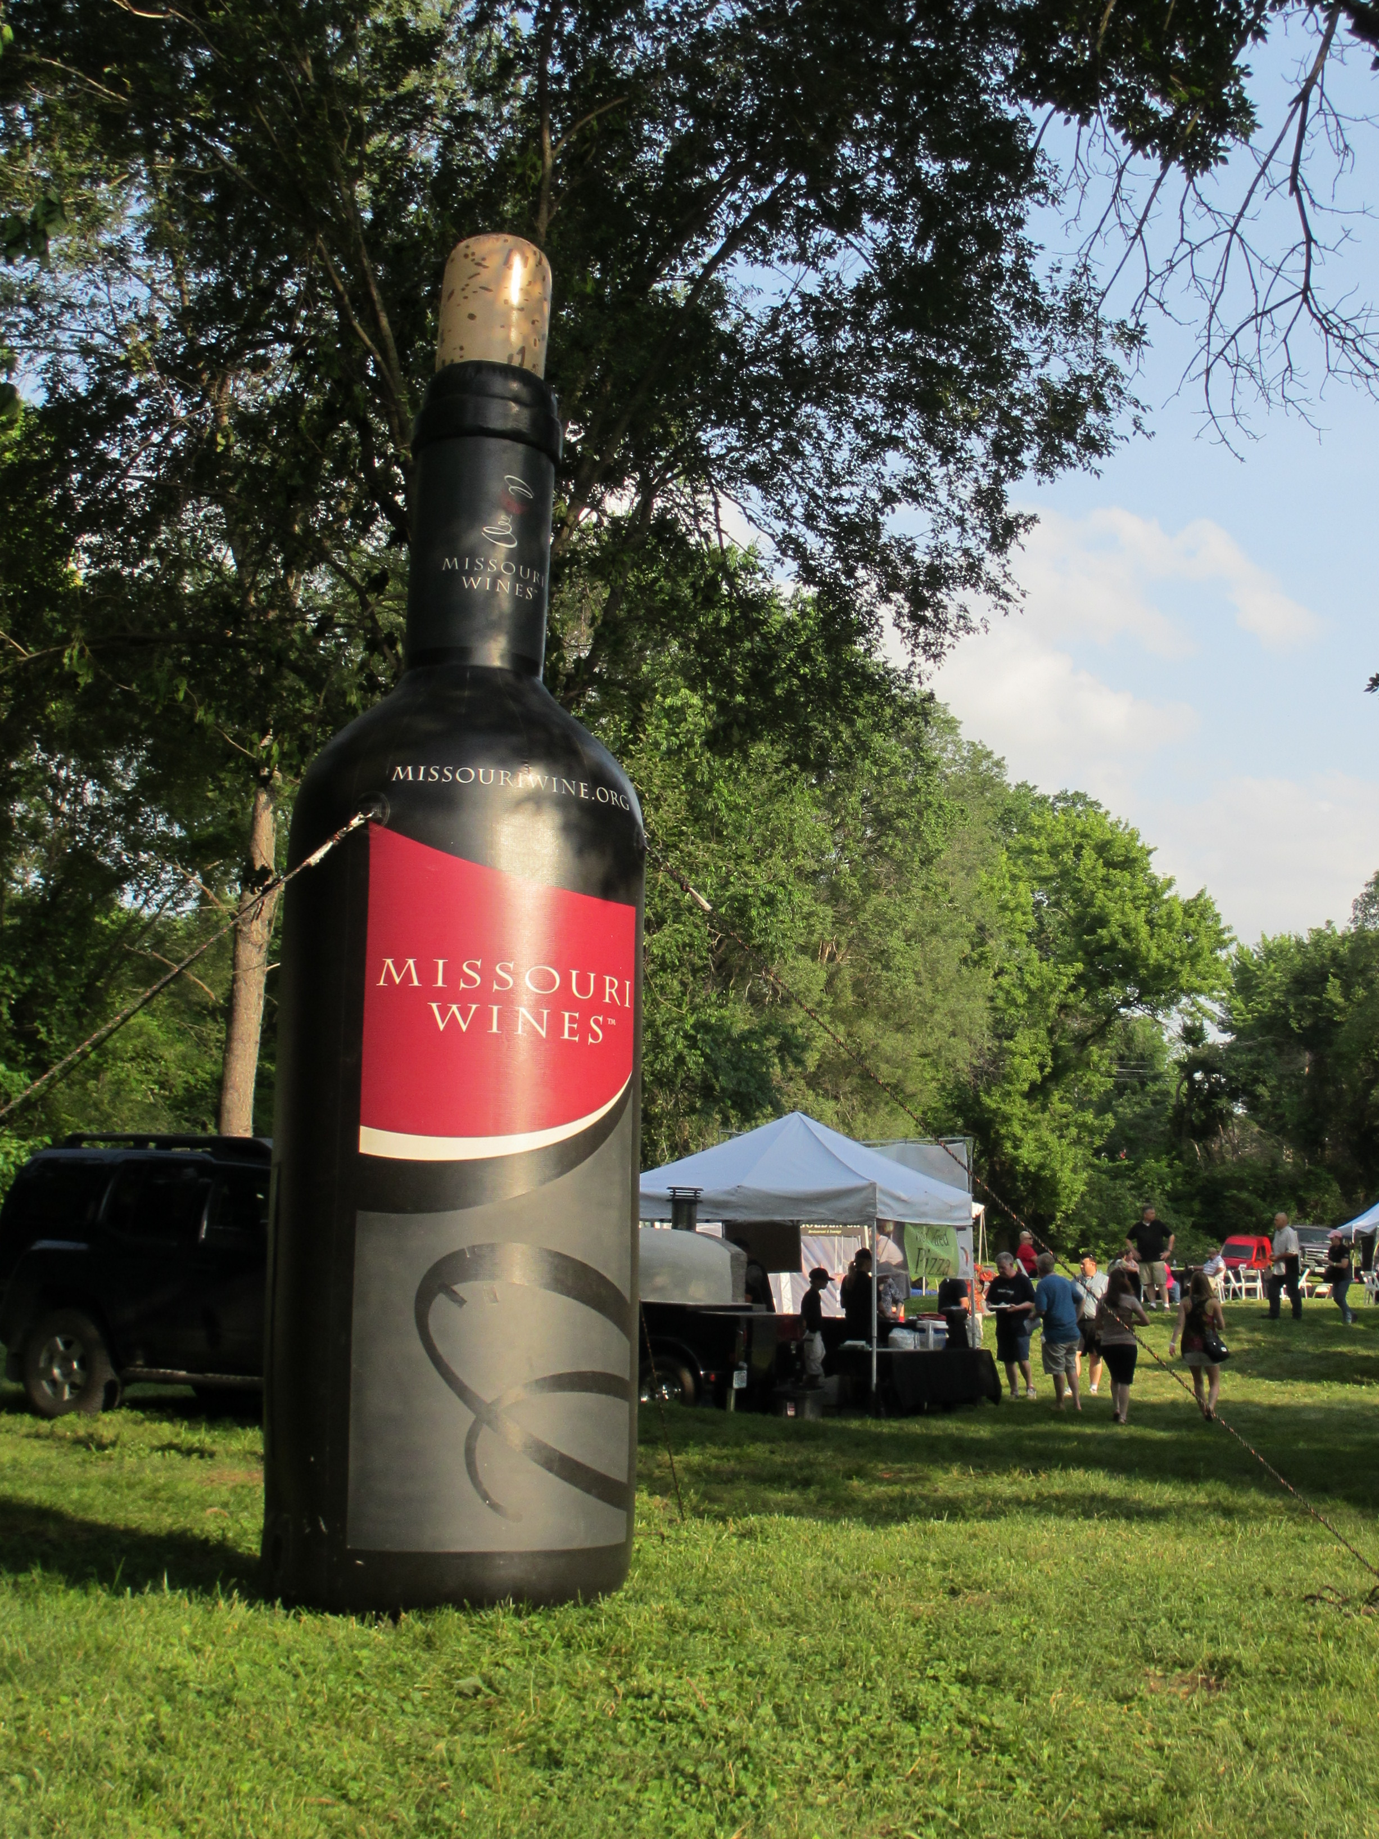
- Missouri Wines Inflatable Bottle Specs:
  - 15 ft. tall, 4 feet wide
  - Electricity required
  - Weights and/or stakes are required to secure the bottle to the ground

